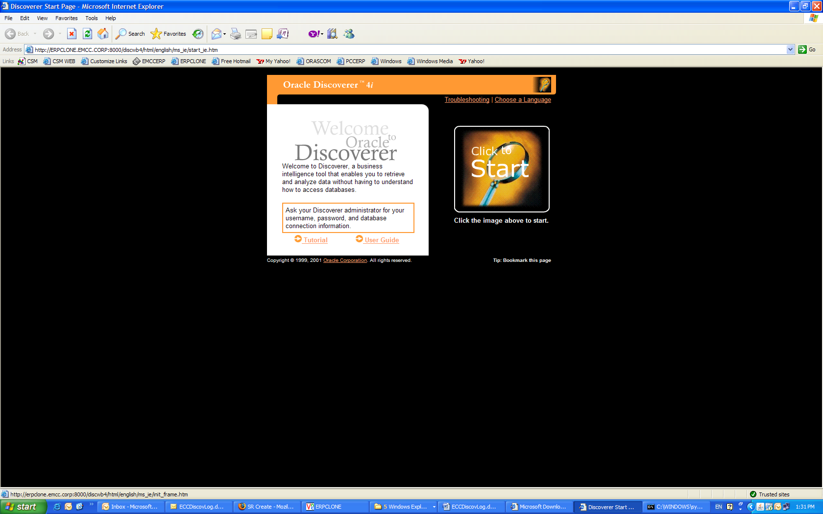

It’s showing me initializing but no change after 1 hr
When I click on java console it’s show me this error

